PRE-LAB 4: PARITY AND GENERATOR CHECKER

TASK 1

AND CIRCUIT REALIZATION 3 VARIABLE

PA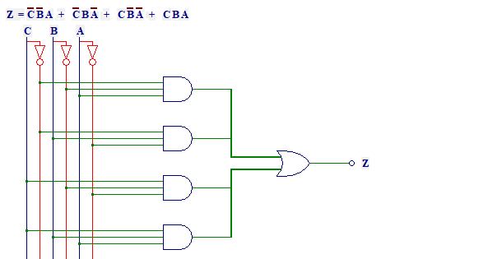

NAND CIRCUIT REALIZATION 3 VARIABLE

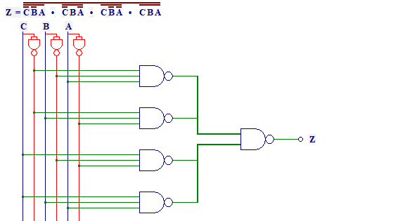

AND CIRCUIT REALIZATION 4 VARIABLE

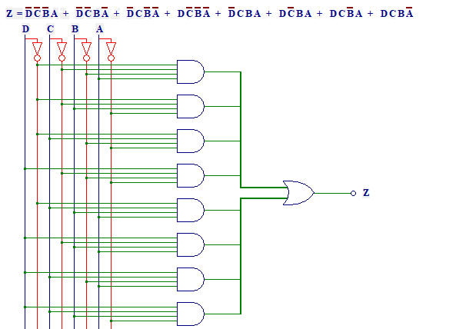

NAND CIRCUIT REALIZATION 4 VARIABLE

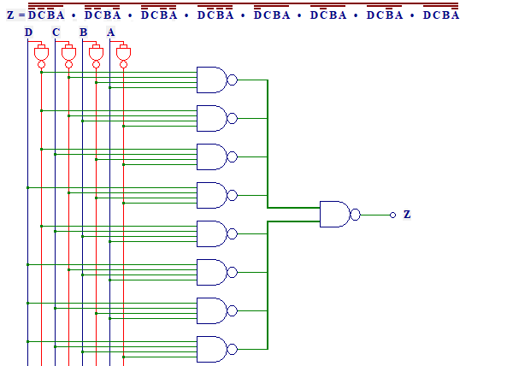

TASK 2

|  |  |  |
| --- | --- | --- |
| X | Y | P |
| 0 | 0 | 0 |
| 0 | 1 | 1 |
| 1 | 0 | 1 |
| 1 | 1 | 0 |

x y y’ y

|  |  |
| --- | --- |
| 0 |  |
|  | 0 |

P= X’Y + XY’

TASK 3

AND CIRCUIT REALIZATION

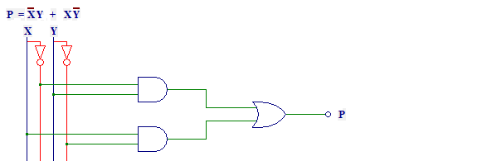

NAND CIRCUIT REALIZATION

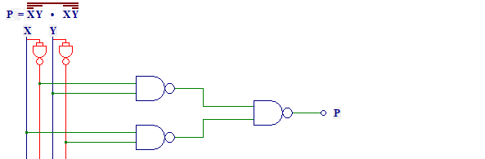

TASK 4

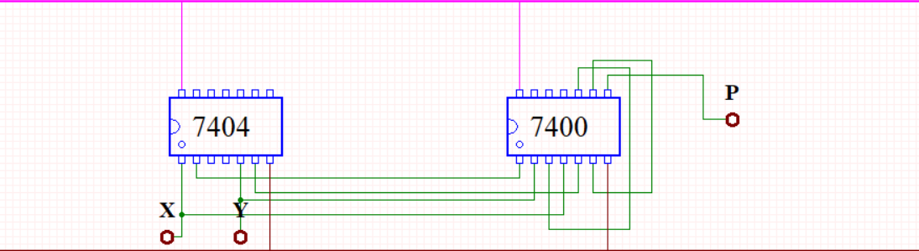

TASK 5

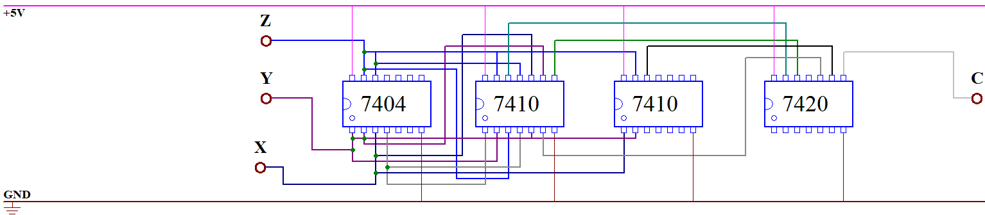

TASK 6

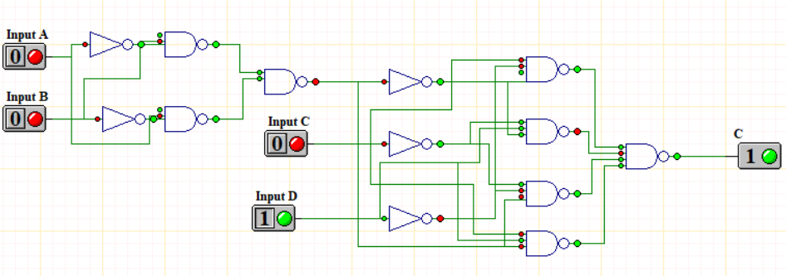

TASK 7

